11/26/2019

ACME Entertainment Pty Ltd

South Metropolitan TAFE

Optimization Report

Rapid Application Development

Table of Contents

Introduction 2

What is Code Optimization? 3

Advantages of Code Optimization 3

PHP Beautifier 4

ACME Login 4

ACME Login GUI 4

Admin Login 5

Admin Login GUI 5

Connect 6

Dislike Analytic 6

Dislike Analytic Display 6

Header 7

Index 7

Like 7

Like Analytic 8

Like Analytic Display 8

Member Removal 9

Member List 9

Page View 10

Search 10

Show All Movies 11

Subscribe 11

Top 10 Movie Searched 12

Unsubscribe 12

CSS Beautifier 13

RAD Design 13

HTML Beautifier 14

Top 10 14

Bibliography 15

Glossary of Term 15

# Introduction

This optimisation report will choose an appropriate code optimiser to ensure the code is perform in a correct way and easier to let other developers take over.

The information will include in this performance report as following:

* Explain the definition of code optimizers
* Explain why the selected tools will be beneficial for the project
* Attach screenshots to show how the code optimizer works

# What is Code Optimization?

Code optimization is any method of code adjustment to improve code quality and efficiency. The basic requirements are code optimizer program must have the same output as its non-optimized version. This will improve the code by making it consume fewer resources so the program will run faster. Code optimization process should meet the following points:

* Code optimization should increase the speed and performance of the program
* The output of code optimization should same as non-optimized version

## Advantages of Code Optimization

* Code optimization helps to makes the code good and maintainable
* Code optimization will prevent future defects as the code size reduced
* Code optimization makes code can be understand easily as the code is restructured and duplicate code is eliminated

# PHP Beautifier

PHP Beautifier is an online tool to make PHP more readable. It gives the PHP code proper indentation with spaces or tabs. The screenshots of php code that used PHP beautifier as following:

## ACME Login

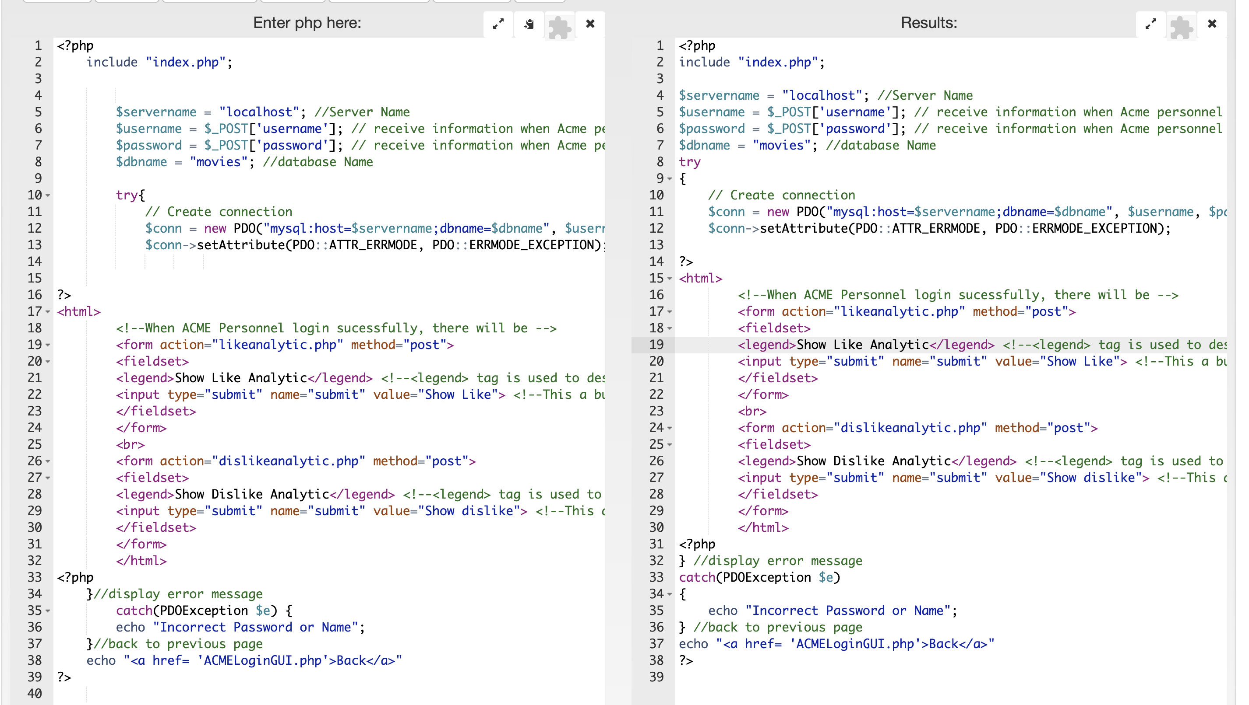

## ACME Login GUI

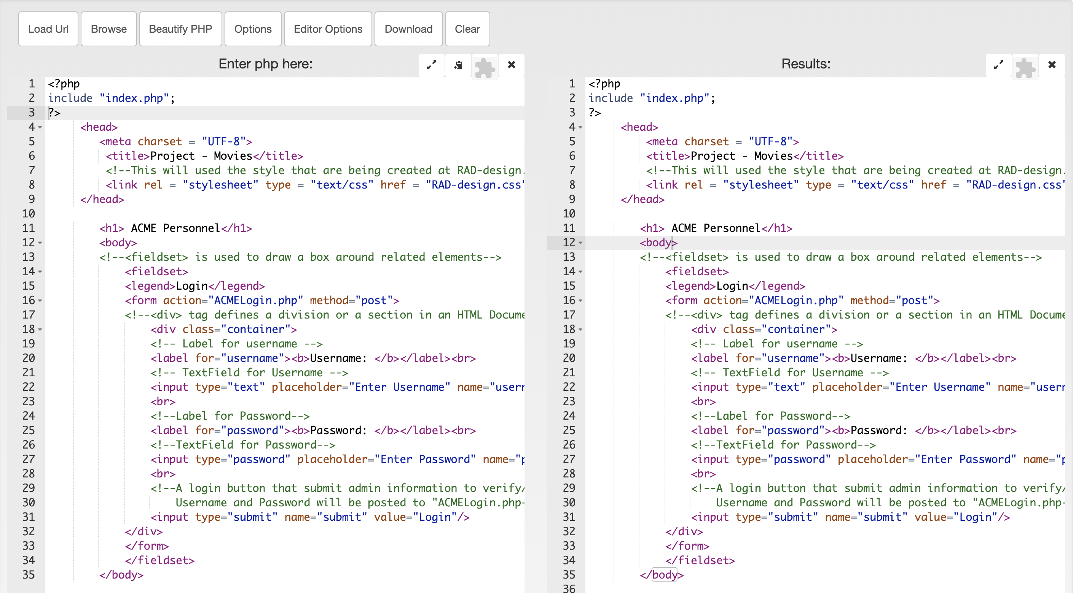

## Admin Login

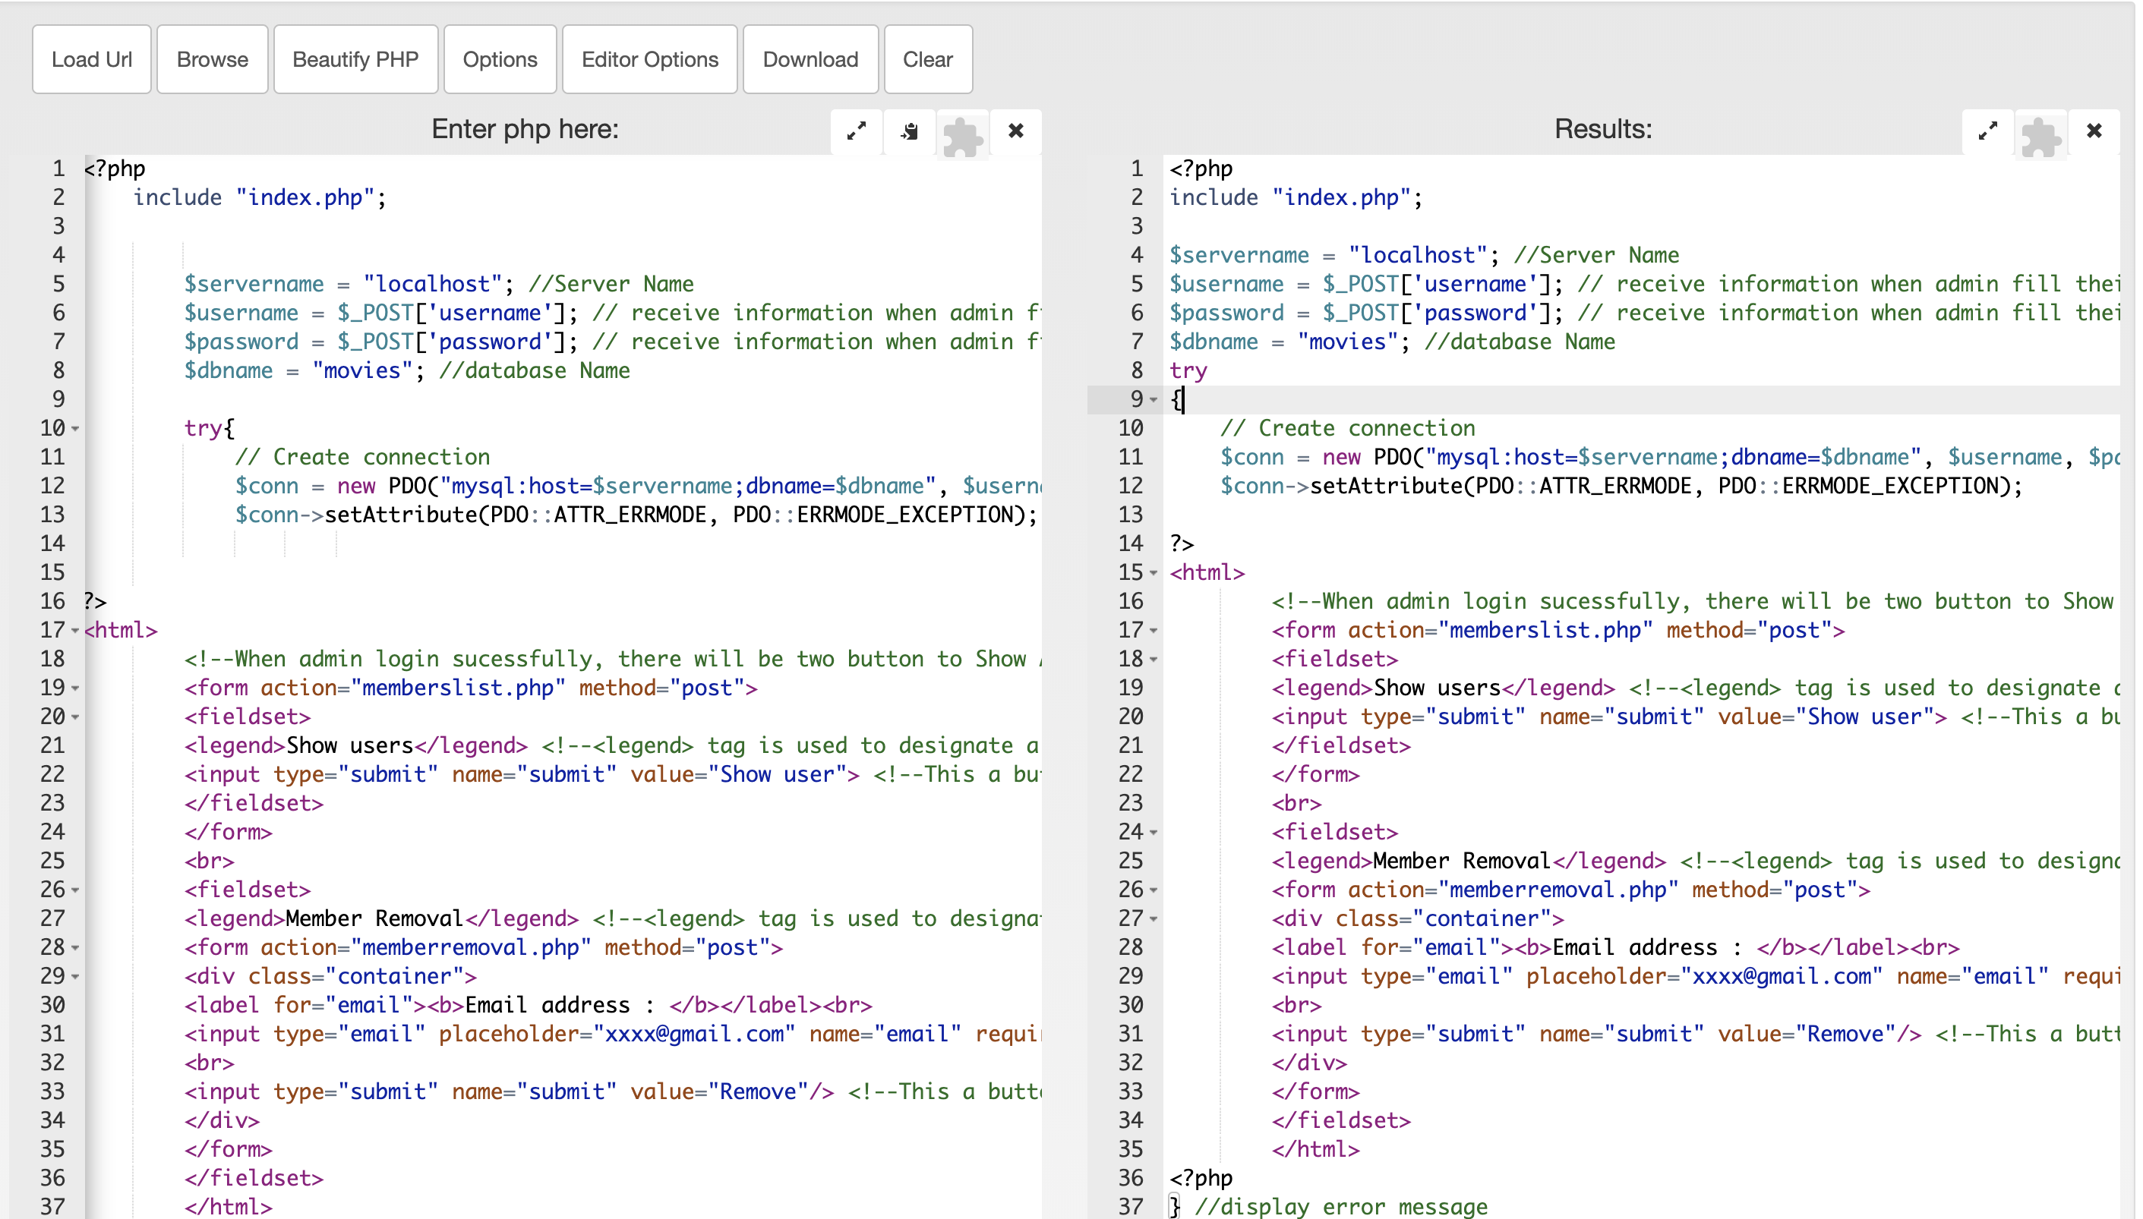

## Admin Login GUI

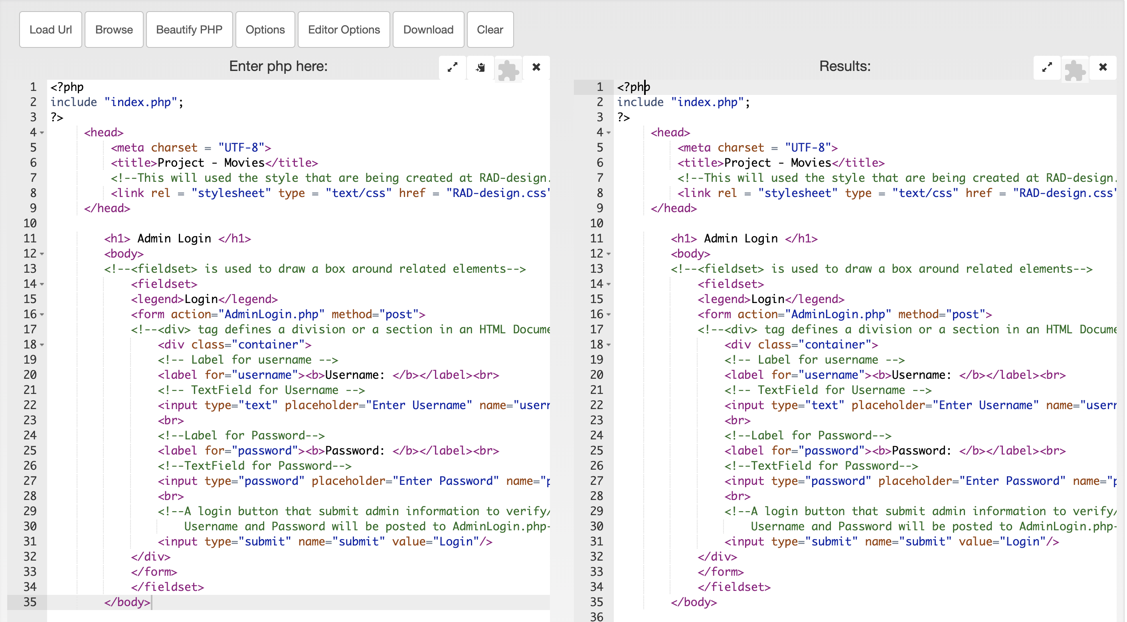

## Connect

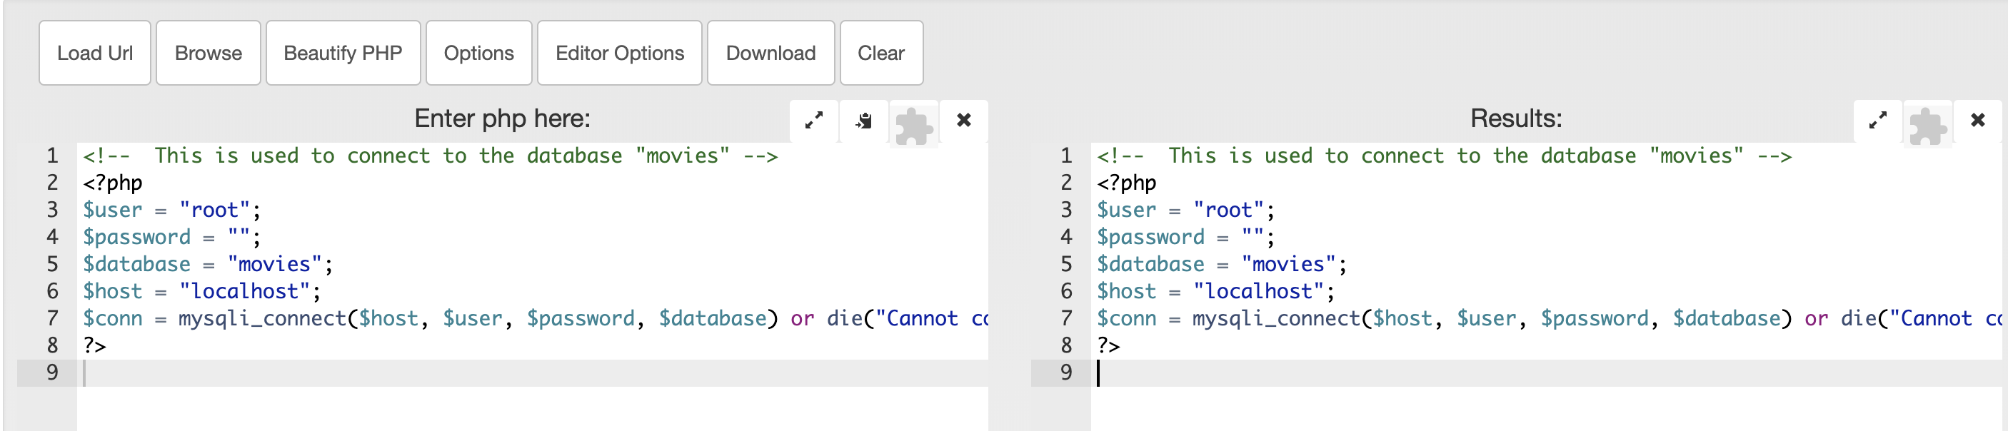

## Dislike Analytic

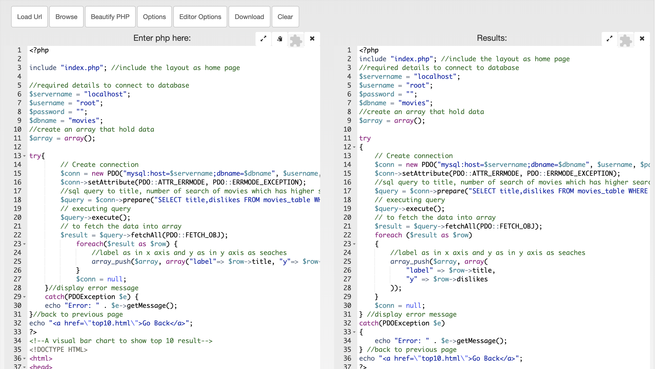

## Dislike Analytic Display

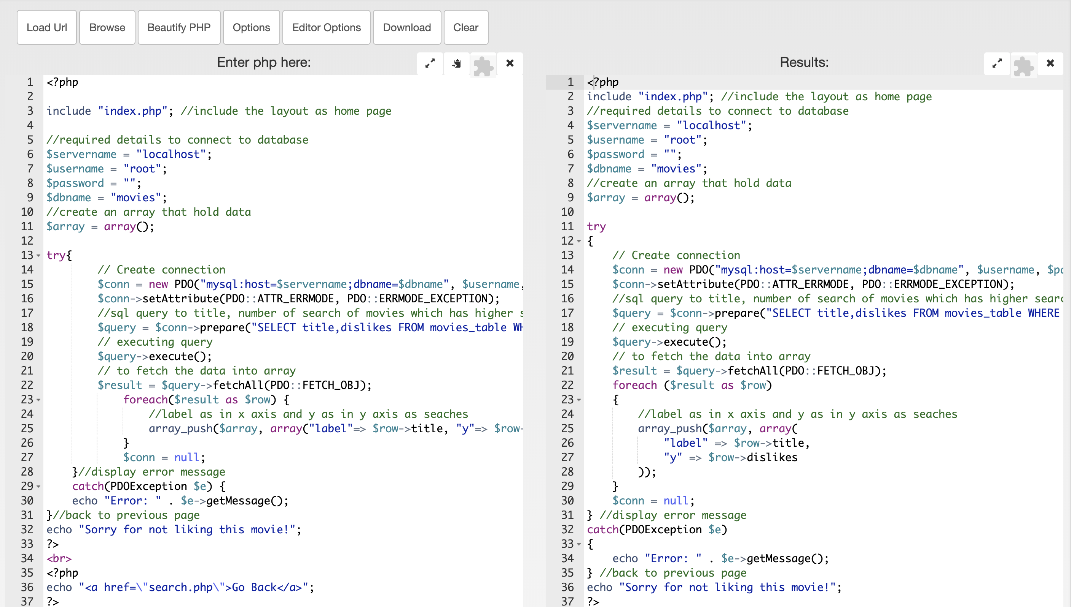

## Header

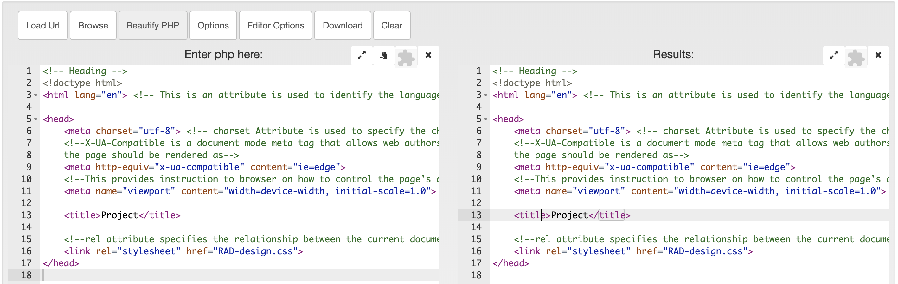

## Index

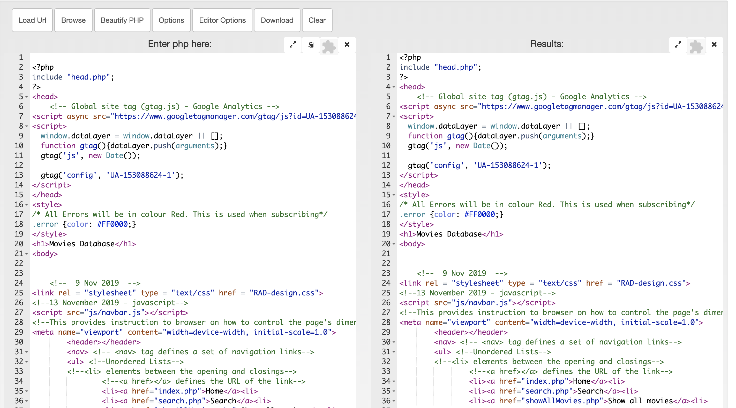

## Like

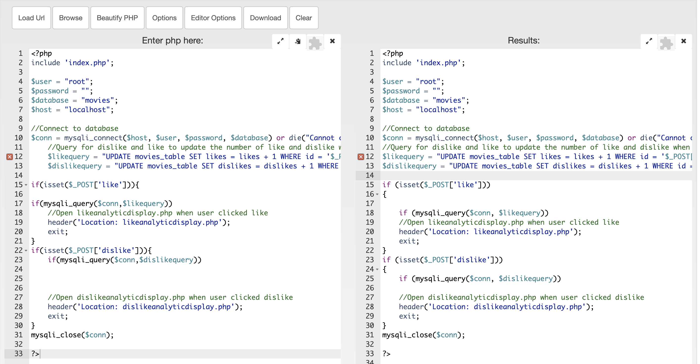

## Like Analytic

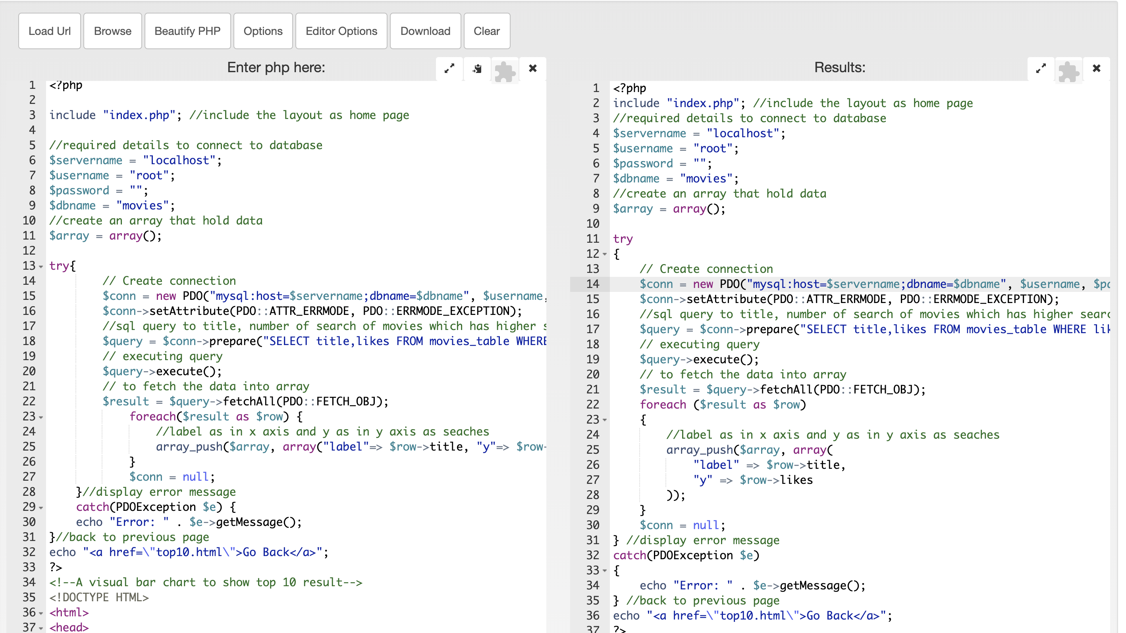

## Like Analytic Display

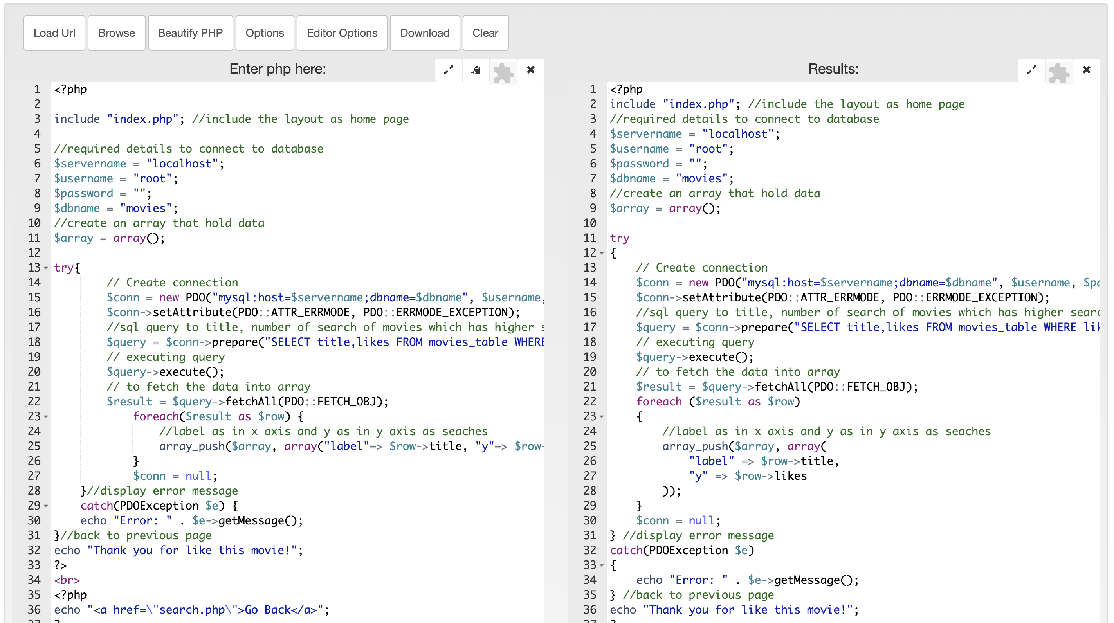

## Member Removal

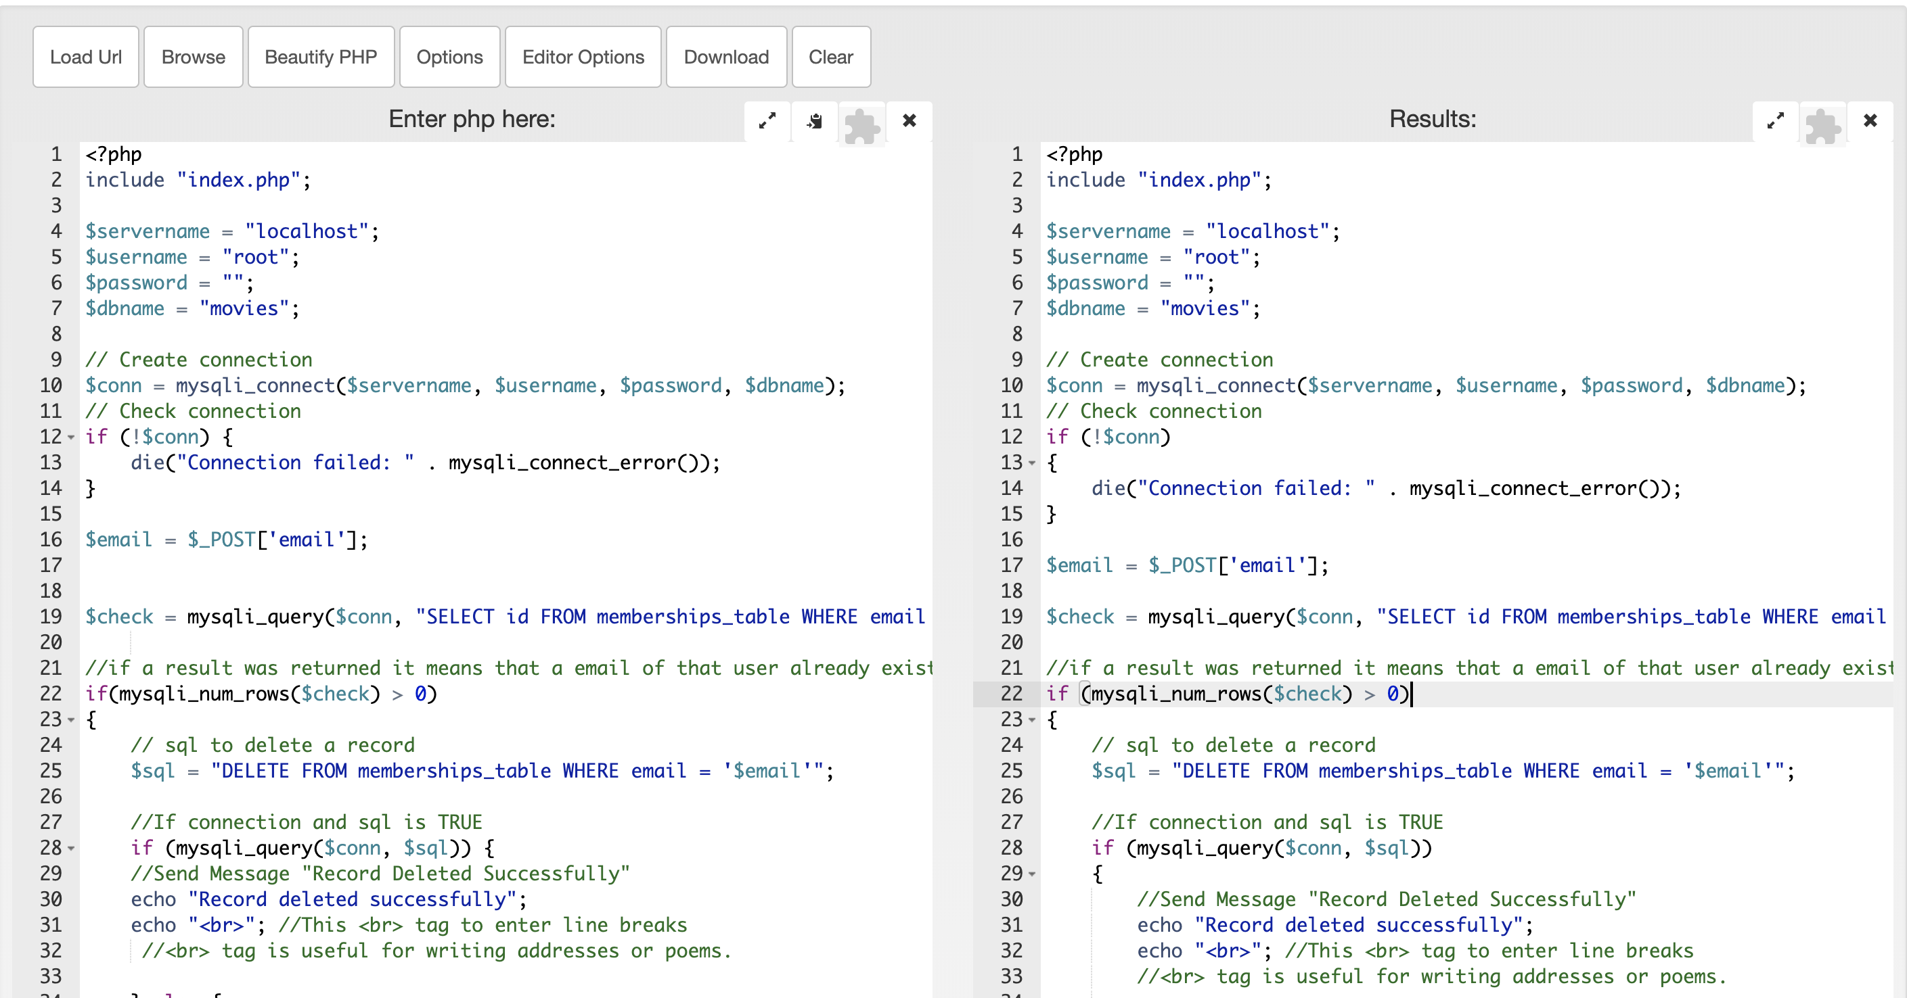

## Member List

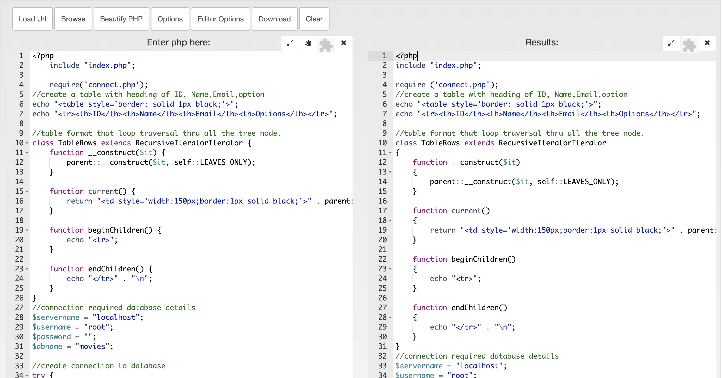

## Page View

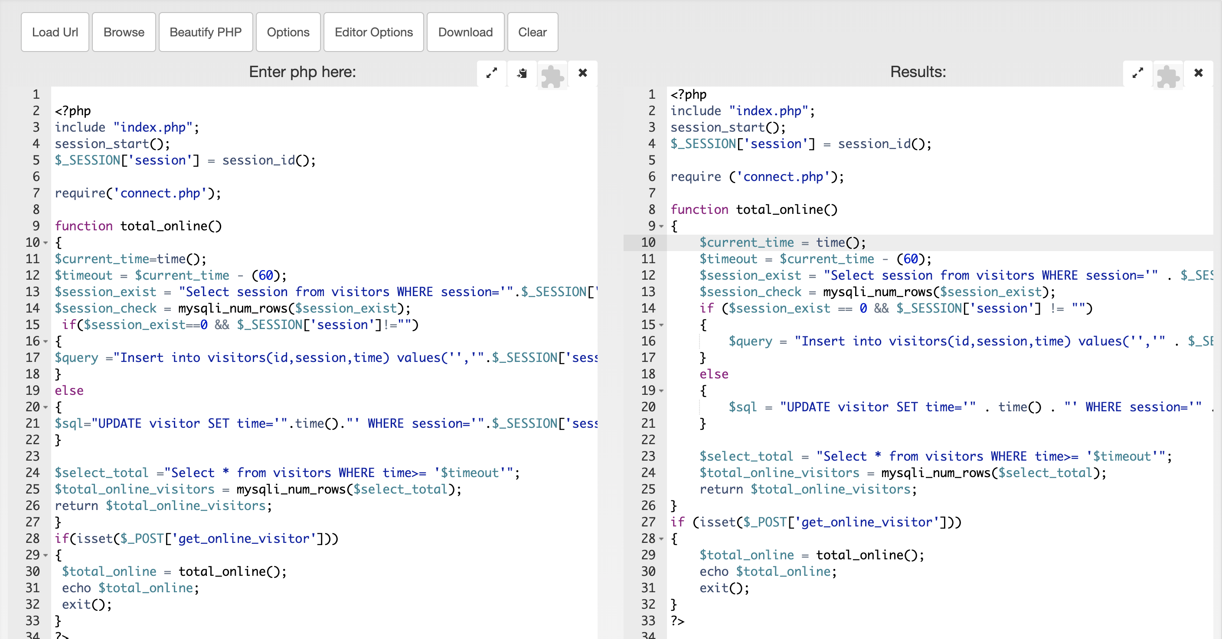

## Search

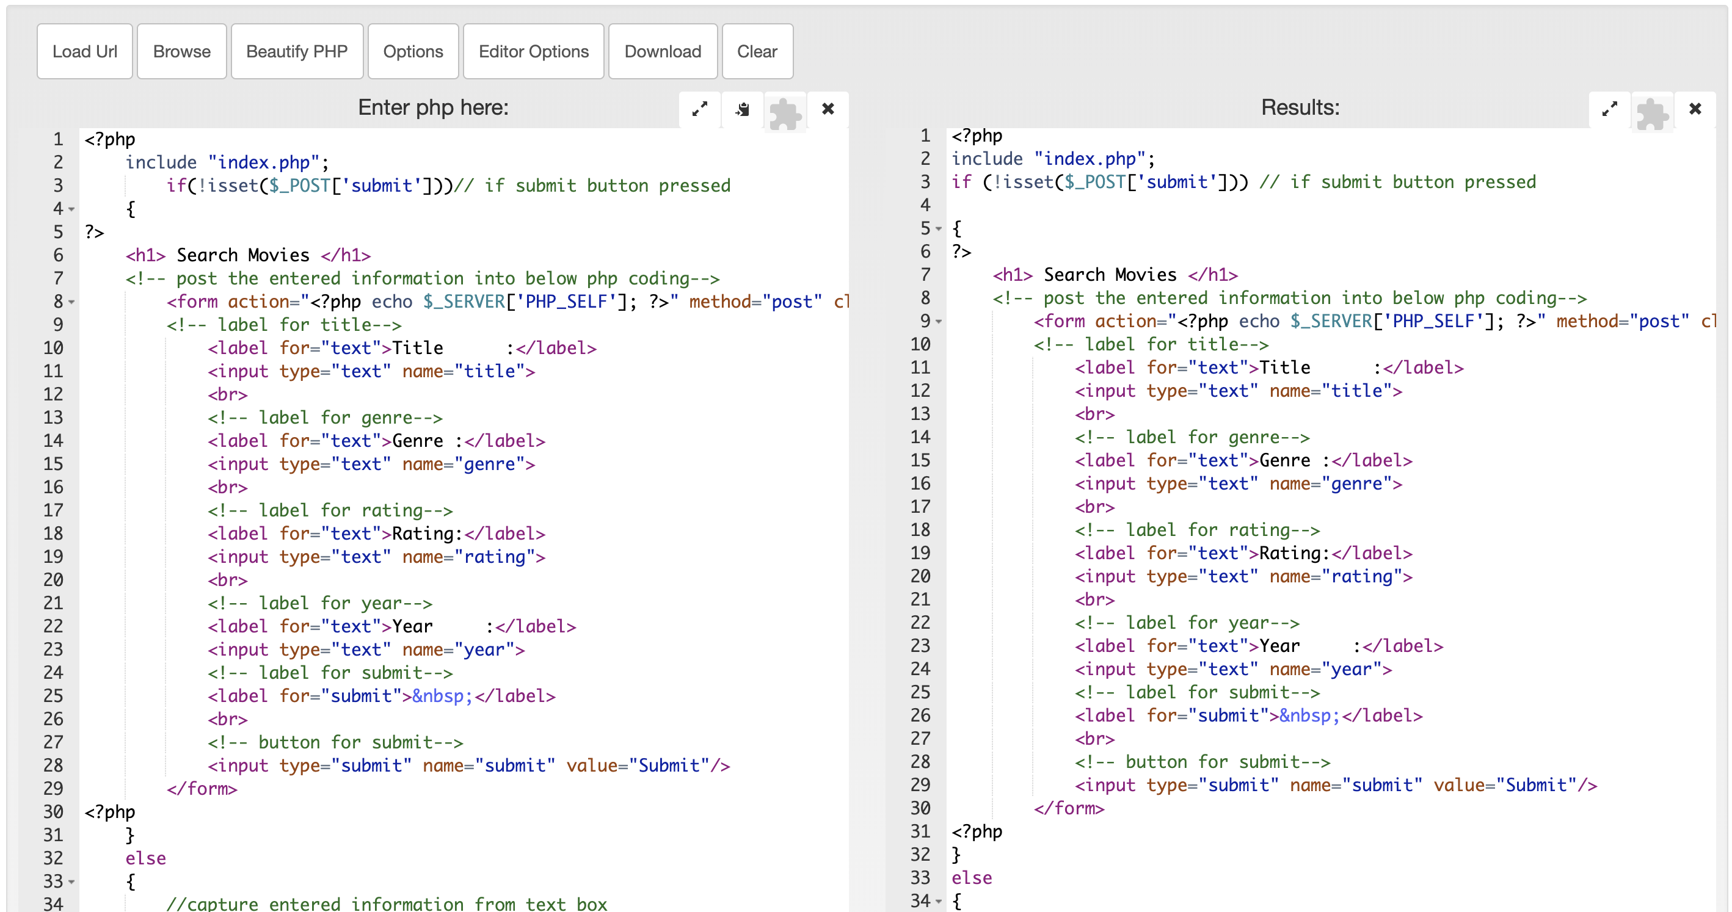

## Show All Movies

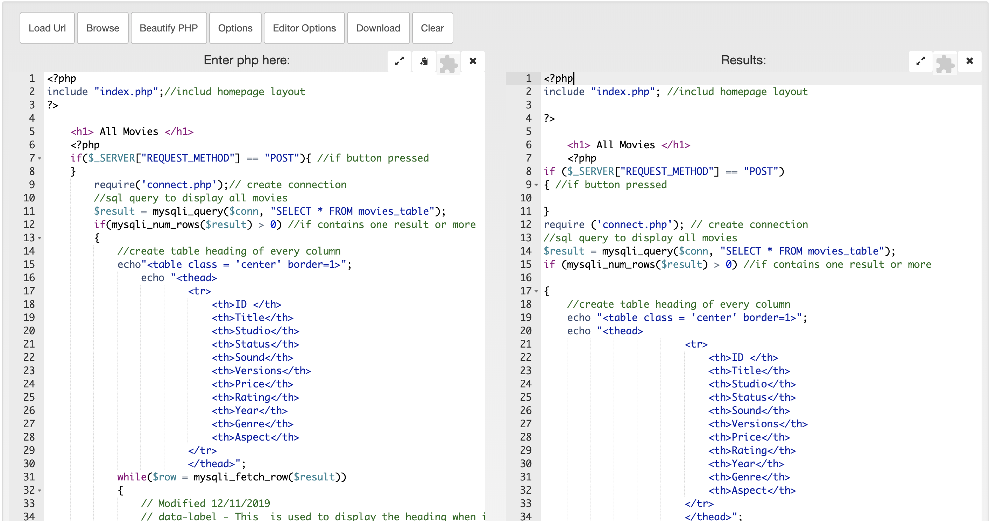

## Subscribe

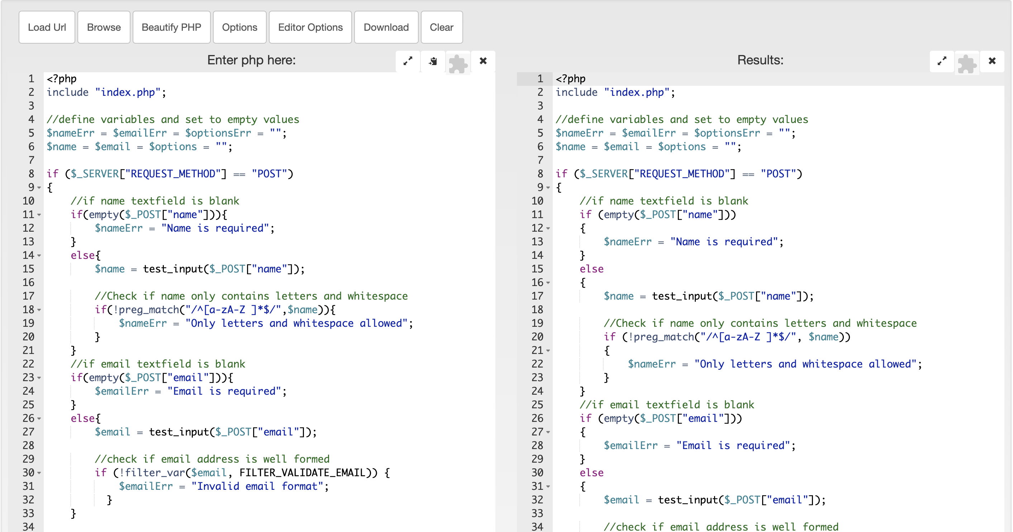

## Top 10 Movie Searched

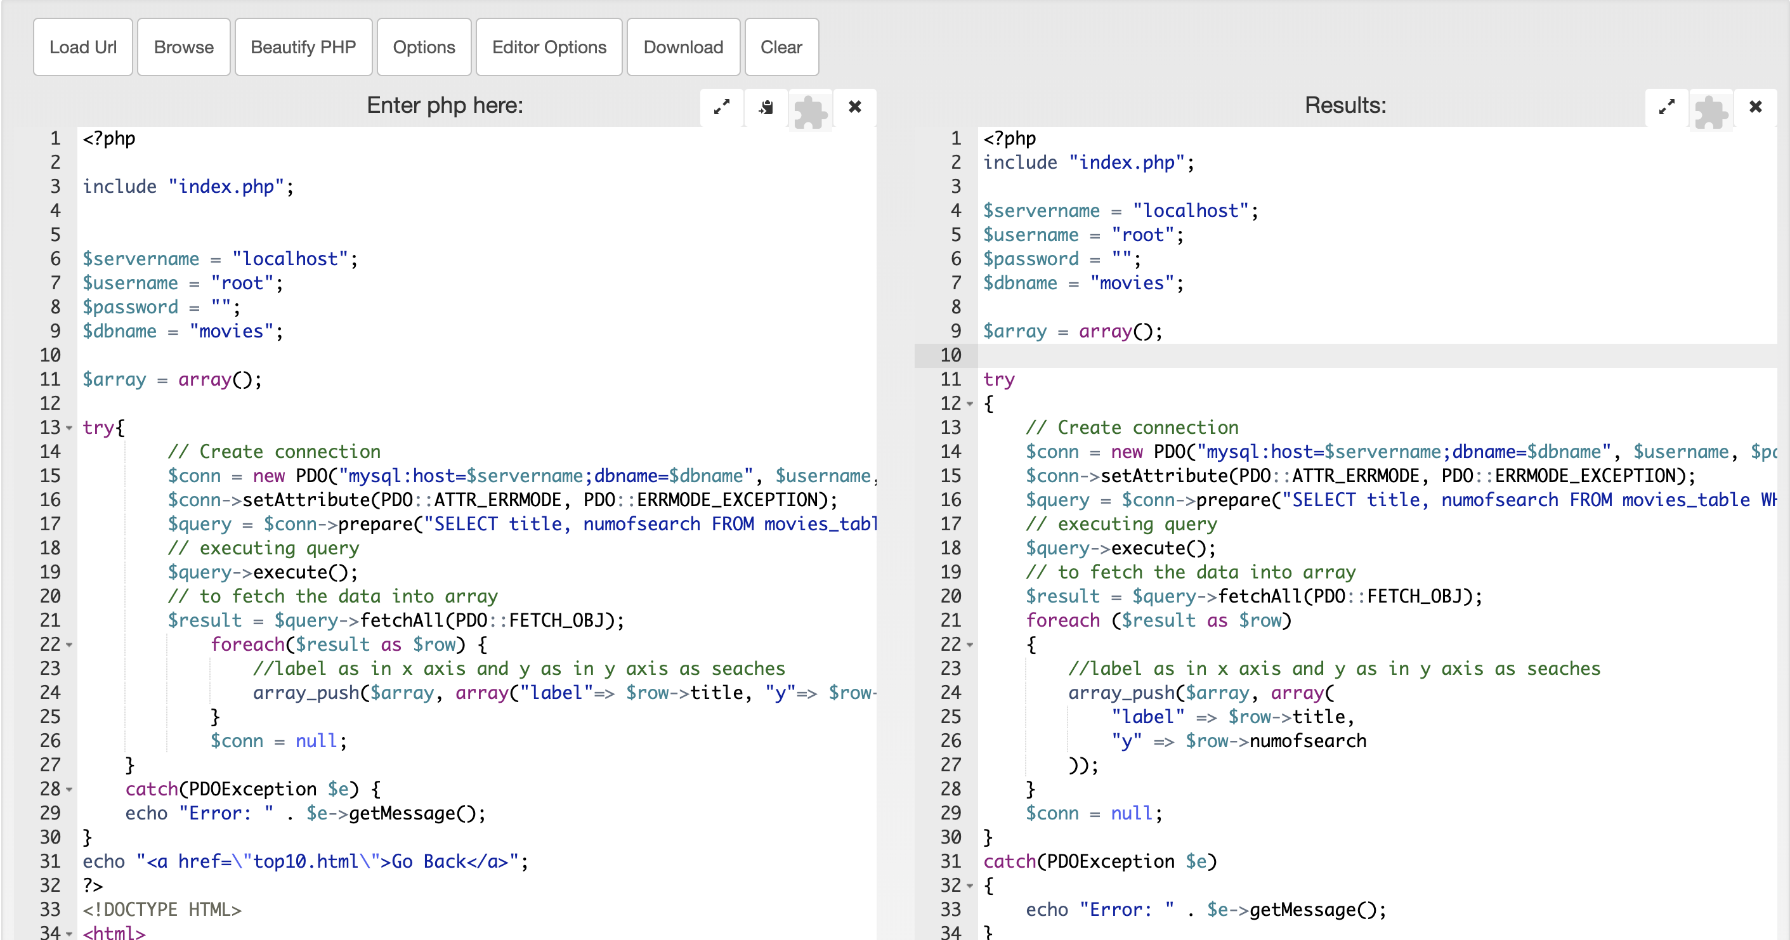

## Unsubscribe

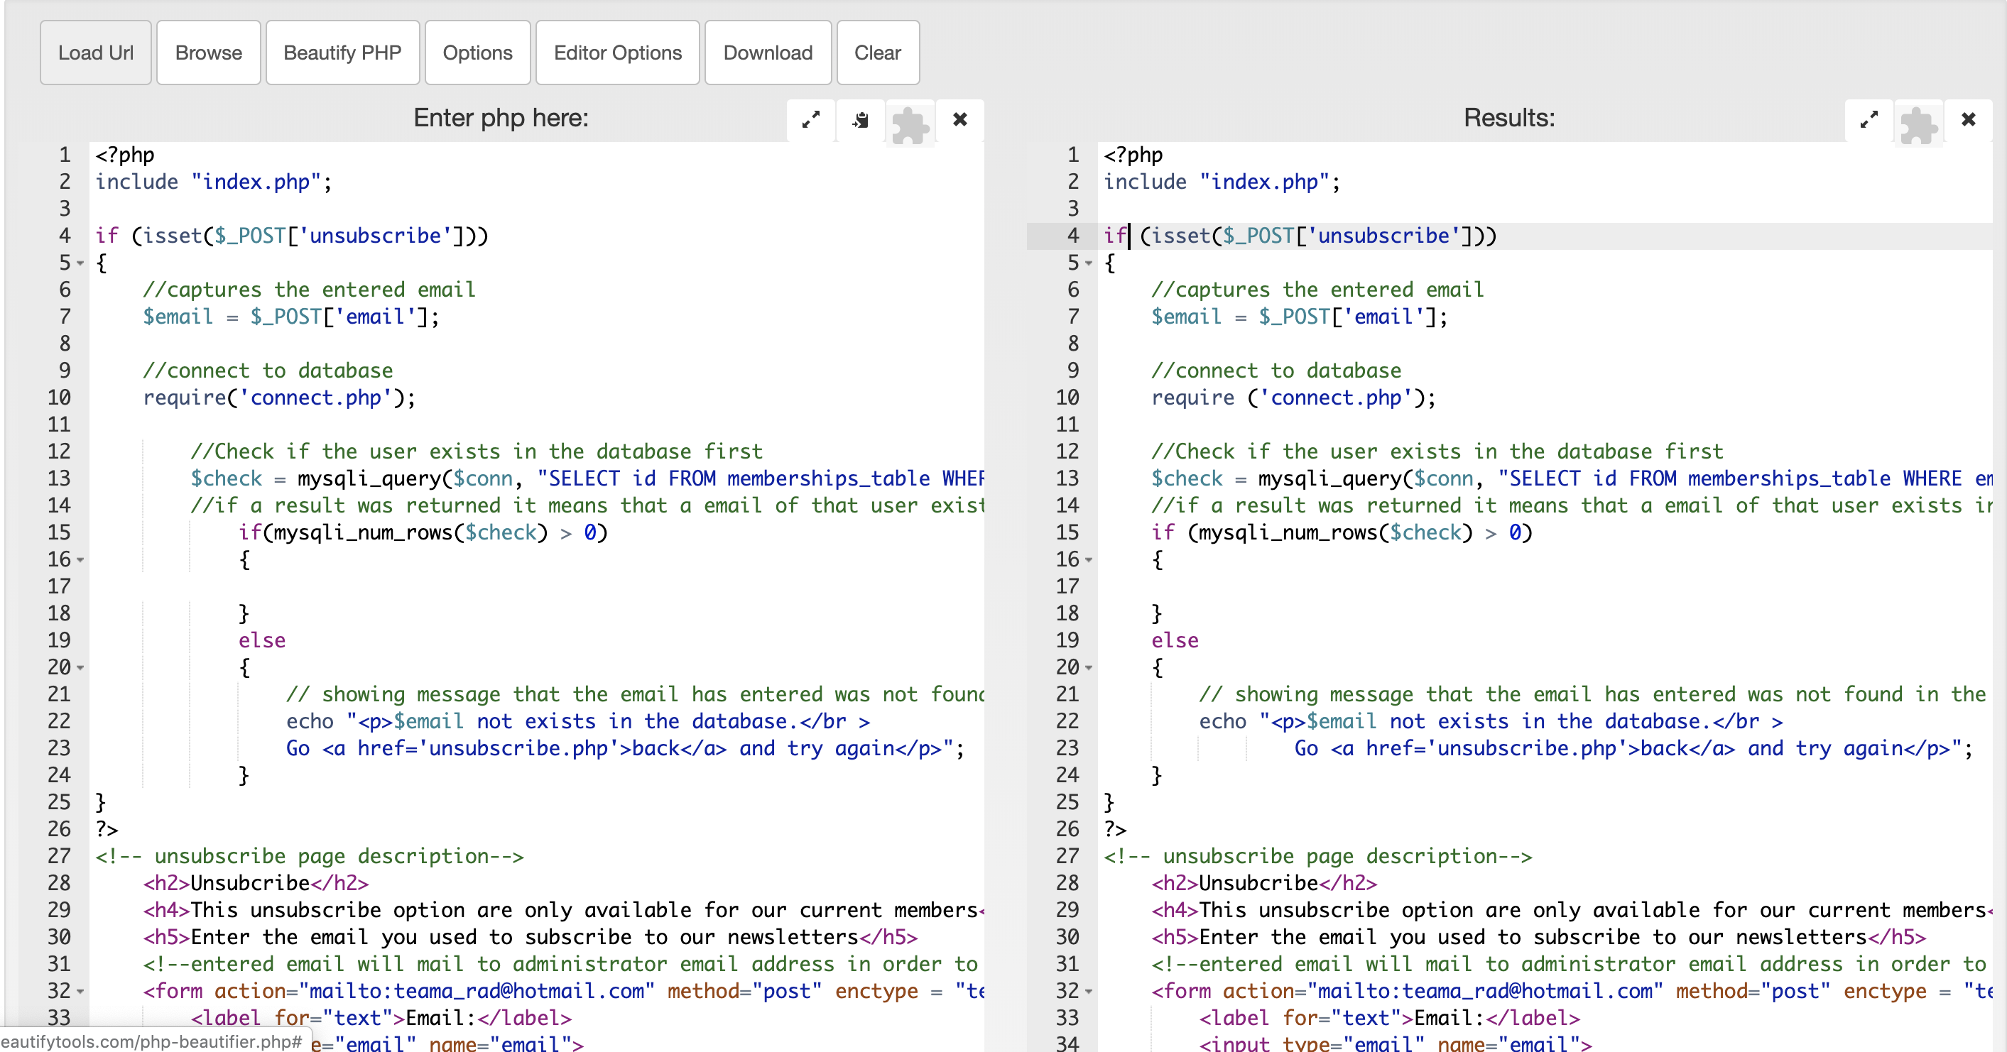

# CSS Beautifier

CSS Beautifier is an online tool to make code more readable. The editor has the option to choose different themes and font sizes. The syntax highlighter, auto completion, code errors and warnings are also enabled to write code more easily.

## RAD Design

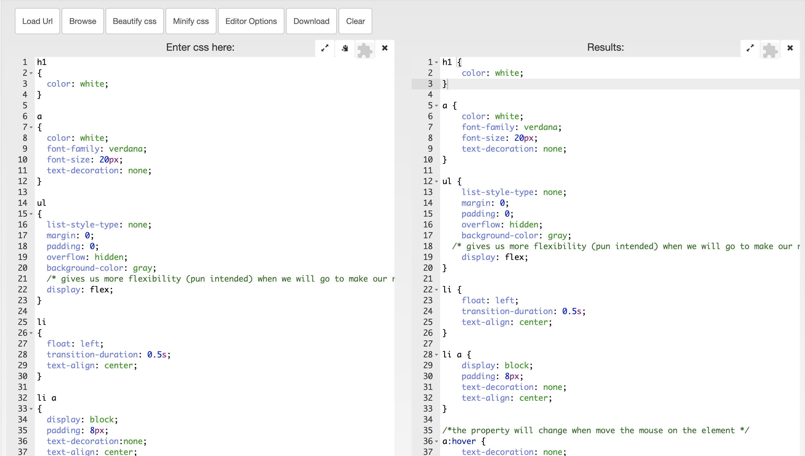

# HTML Beautifier

HTML Beautifier is an online tool to make code more readable. It gives the HTML code proper indentation. Online HTML Beautifier also beautifies the CSS and JavaScript between the style and script tags.

## Top 10

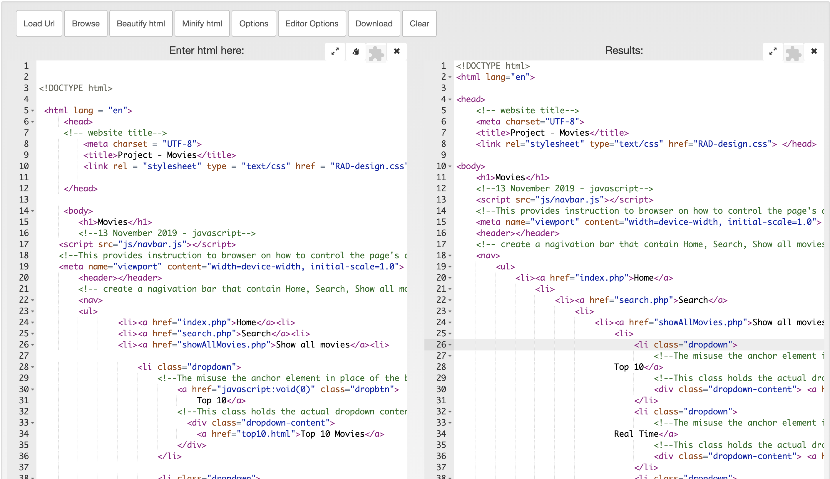

# Bibliography

*Code Optimization*. (n.d.). Retrieved from ScienceDirect: https://www.sciencedirect.com/topics/computer-science/code-optimization

*Code Optimzation*. (n.d.). Retrieved from PVS-Studio: https://www.viva64.com/en/t/0084/

*CSS Beautifier*. (n.d.). Retrieved from Beautify Tools: http://beautifytools.com/css-beautifier.php

*HTML Beautifier*. (n.d.). Retrieved from Beautify Tools: http://beautifytools.com/html-beautifier.php

*PHP Beautifier*. (n.d.). Retrieved from Beautify Tools: http://beautifytools.com/php-beautifier.php

# Glossary of Term

**Hypertext Markup Language (HTML)** - Is a standard markup language for documents designed to be displayed in a web browser

**Cascading Style Sheets (CSS)** -Is a stylesheet language used to describe the presentation of a document written in HTML or XML

**Hypertext Preprocessor (PHP)** -Is a server scripting language, and a powerful tool for making dynamic and interactive webpage

**JavaScript** - Is an object-oriented computer programming language commonly used to create interactive effects with web browsers

**Structured Query Language (SQL)** - Is used to communicate with a database and the standard language for relational database management system